Detailed physical modeling of wildland fire dynamics at field scale – An experimentally informed evaluation

Muller et al.

In this case the experimental data was used to understand the fidelity of CFD of simulating wildland fire dynamics.

|  |  |
| --- | --- |
| What was evaluated? | What was found? |
| Impact of level of details of fuel structure and wind. | Has minor impact |
| Fire behavior comparison (Experiment vs Simulation)  Spread rate  Combustion processes such as heat flux | Model reproduced mid-range of fire behavior of experimental observation.  Local combustion is qualitatively consistent. |

Focused the measurements of

* Gas-phase temperature -flame structure
* Flow at surface level-convective processes
* Radiative heat flux ahead the fire front – fire spreading

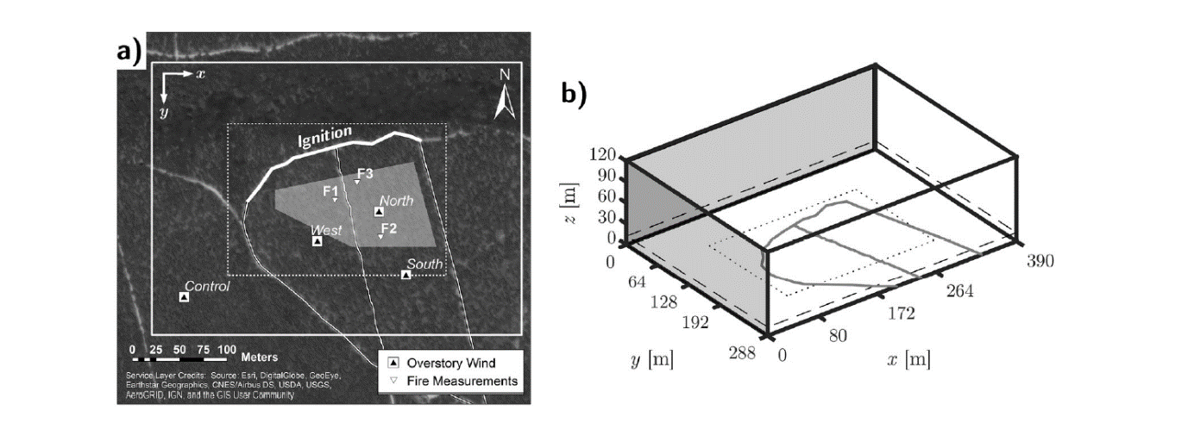

Comparison with my input data

|  |  |
| --- | --- |
| **This experiment** | **The experiment I am modelling** |
| Done in 2014 | Done in 2016 |
| Same vegetation type: Pitch pine | Same vegetation type: Pitch pine |
| Same location | Same location |
| Moderate to high intensity fire with localized crown fire | Localized crown fire |
| Same type of measuring devices (thermo couples, velocity, het flux) | Same type of measuring devices (thermo couples, velocity, het flux) |
| WFDS 9977 | FDS modified 6.6.0 |
| Vegetation input parameters: see the image 1 below | Vegetation input parameters: see the image 2 below |
| Wind: 3.9 m/s at U12  Log and DFSEM | Wind: 1.4 m/s at U10  SEM |
| Domain:390 m x 280 m x 121.5 m  Resolution:0.5 m x 0.5 m (fire spread region)  1.0 m x 1.0 m (surrounding) | Domain:360 m x 160 m x 140 m  Resolution:0.5 m x 0.5 m (firebrand region)  1.0 m x 1.0 m (surrounding) |

Results

* Over prediction of mean-spread rate to 30%
* Flaming characteristics
  + Simulation 954-1062 0C
  + Experiment 814-1017 0C
* Flaming height, temperature range and residence time are close with the experiment.
* Fuel consumption is over predicted in lower layers.
* Line fire decay inversely proportional decay in the intermittent flame region (read more)

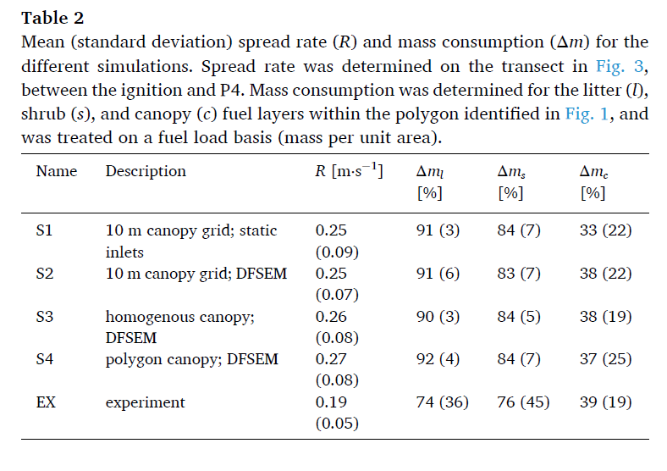

Uncertainties

* Drag reduction because of the fuel consumption
* Downdraft vortices
* Mechanism for generation of firebrands.
* Numerical grid size should be small to capture radiative absorption.

Quantifying production of hot firebrands using a fire-resistant fabric

Adusumilli et al.

Objective: characterizing the charring behavior of fire-resistant fabric.

Illustrate the fabric usage for firebrand generation studies.

Conclusion: Char mark area is an exponential function of the temperature, power input and time of exposure.

Ration of (hot firebrands/total firebrands) = 0.3 to 0.05

|  |  |
| --- | --- |
|  |  |

Findings

* At higher temperature charring is irrespective with contact time.
* At lower temperature charring was observed only the contact time is sufficient.

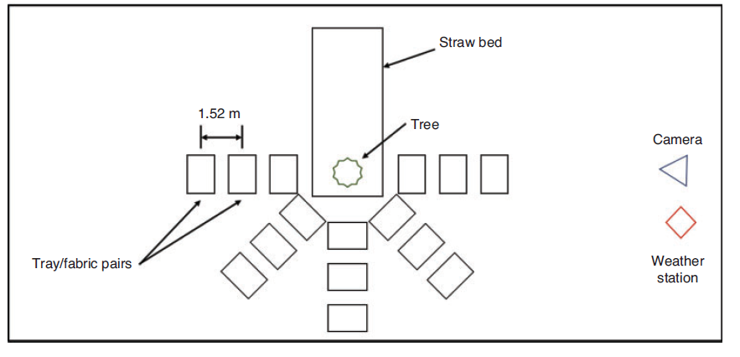

Findings

* Both tree types of trees (UT and FR) burnt similarly
* Both types of trees produced firebrands.
* The number of char marks lower by factor 5 for FR treated trees compared to untreated.
* The larger firebrands produced by FR treated trees, but the larger char marks from UT trees.

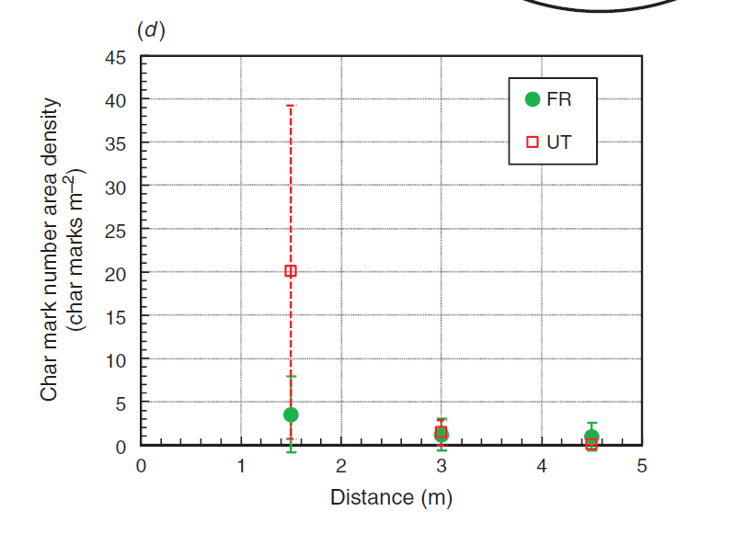

Simulation (Douglas fir tree) with Haider and Levenspiel + SECOND ORDER PARTICLE DISTRIBUTION

|  |  |
| --- | --- |
| Distance (m) | number density ( m-2) |
| 0.55 | 44.195 |
| 1 | 8.913 |
| 1.45 | 0.606 |

Experimental results and estimation

|  |  |  |  |  |
| --- | --- | --- | --- | --- |
| Distance (m) | char mark number density ( m-2) | | Estimation to the simulation | |
| UT | FR | UT | FR |
| 1.5 | 20.056 | 3.510 | 40.752 (0.55 m) | 6.394 (0.55 m) |
| 3 | 1.504 | 1.003 | 30.083 (1.00 m) | 4.903 (1.00 m) |
| 4.5 | 0.251 | 1.003 | 20.971 (1.45 m) | 3.636 (1.45 m) |

**second order polynomial used.